How to Install & Setup SOAP UI on Desktop

1. Install SOAP UI
   1. Download and Install SOAP UI Open Source version
   2. Setup SOAPUI_HOME environment Variable and update path as follows

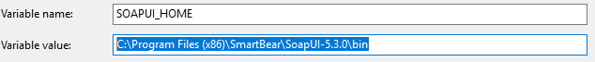



1. Setup SOAP UI to read and use external jar files
   1. Copy the external jar files to “*\ext*” folder in SOAP UI
   2. Restart the SOAP UI so that the jar files are detected

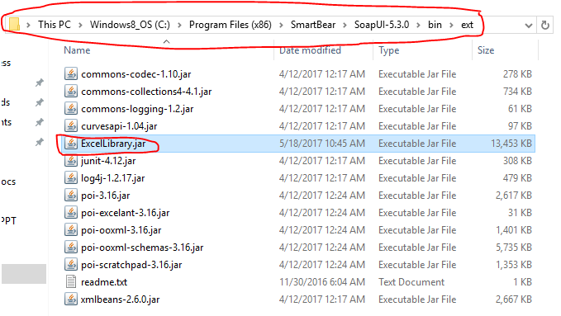

* 1. If the jar files are detected by SOAP UI, then it can be verified in Soap UI log file as shown below

